India Overspeed Warning – Fixed LED Telltale, Fixed/Dedicated RTT, and Chime - CGEA 1.3

Functional Description

The purpose of the India Overspeed Warning is to Alert the driver that the vehicle indicated speed has transitioned in increasing value through 80 km/h indicated, and then again with a more severe warning when vehicle speed has transitioned in increasing value through 120 km/h indicated. Upon transitioning above 80 km/h the overspeed telltale/RTT is illuminated and will remain illuminated until vehicle speed drops below 80 km/h with hysteresis. Upon transitioning above 80 km/h a single chime is sounded. Upon transitioning above 120 km/h a continuous chime is sounded and will continue to sound until vehicle speed drops below 120 km/h with hysteresis.

The India Overspeed Warning is required per regulation for all vehicles manufactured on or after 01April2018. Vehicles manufactured on or after 01April 2018 will not be saleable in India without this function. See RCN Ind-004458/10 for more information.

Version 2.0 of this STSS addresses India updated regulation relative to Overspeed Warning as per
RCN IND-R-013113/3 released into Ford system 05May2018 and clarifies updates to India Regulation AIS-145_F. This update changes overspeed warning such that the lower speed warning must sound an audible warning not less than 1cycle/2minutes. Prior regulation only required the audible warning to sound once upon entering the lower speed warning condition. This update also increases the threshold for the high speed warning from 100 km/h to 120 km/h. This update must be made for all vehicles manufactured on or after 01Jul2019 or the vehicle will not be saleable in the Indian market.

The India Overspeed Warning correlates the operational mode, the India_Overspeed_Warning _Cfg, and the Veh_V_ActlEng signal to activate the India_Overspeed_Telltale or India_Overspeed_RTT, and sound the appropriate chime.

Interfaces

Interface Context Diagram (I/O Block Diagram)
Figure 1: India Overspeed Warning
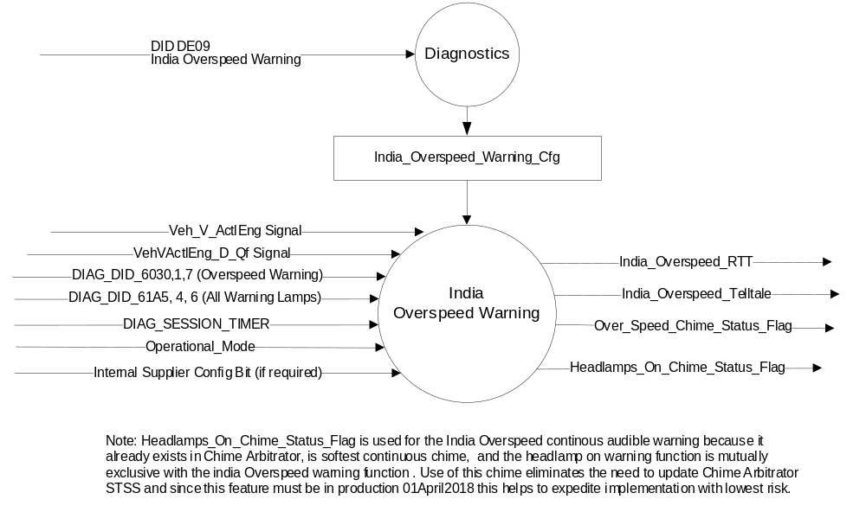

Inputs
- INTERNAL:
- Operational Modes: refer to section Operational Modes
- India_Overspeed_Warning_Cfg
- DIAG_DID_6030,1,7 (Overspeed Warning)
- DIAG_DID_61A5, 4,6 (All Warning Lamps)
- DIAG_SESSION_TIMER
- Internal Supplier Config Bit.

- MUX message on the CAN Bus from the PCM.

- Veh_V_ActlEng Signal
Signal Name | Size (bits) | Detail | Units | Res. | Offset | State  Encoded | Min | Max | Sender
Veh_V_ActlEng | 16 |  | KPH | 0.01 | 0 |  | -0  (0x0000) | 655.35 (0xFFFF) | PCM

- VehVActlEng_D_Qf Signal
Signal Name | Size (bits) | Detail | Units | Res. | Offset | State  Encoded | Min | Max | Sender
VehVActlEng_D_Qf | 2 |  | SED | 1 | 0 |  | 0  (0x0) | 3  (0x3) | PCM
 |  | Faulty |  |  |  | (0x0)
 |  | No_Data_Exists |  |  |  | (0x1)
 |  | Not_Within_  Specifications |  |  |  | (0x2)
 |  | OK |  |  |  | (0x3)

Outputs
- India_Overspeed_RTT, which is used to control the state of the RTT
- Inida_Overspeed_Telltale, which is used to control the state of the LED
- Over_Speed_Chime_Status_Flag
- Headlamps_On_Chime_Status_Flag
NOTE: Only one of the above visual outputs will be employed on any given IPC as per the internal supplier
config bit. The chime function is common for all applications.

Function/Performance

Operational Modes

Mode | Differentiating Vehicle Conditions
Sleep Mode | India Overspeed Warning Flags OFF
Limited Mode | India Overspeed Warning Flags OFF
Normal Mode | India Overspeed Warning Flags ON/OFF
Crank Mode | India Overspeed Warning Flags ON/OFF

Voltage Levels

Refer to the Cluster Features table located in the Operational Modes and Voltage Range Strategies section in this SPSS

Human-Machine Interface

Visual

Indicator Graphics / Display Format


J.011 Symbol

For actual symbol definition see pixel definition section in the message center section.
The pixel representation is based upon the symbol definition database # tbd of the 03-0685 ARL requirement.

Indicator Graphics / Display Format

Indicator Color Coordinates

Amber - Reference SDS IL-0017/IS-0379. May be shown monochromatic in monochromatic displays

Indicator Characteristics

Dedicated/Fixed RTT – India Overspeed RTT (TFT)
LED – India Overspeed Telltale (base)

Audio

Overspeed Warning Chime is sounded upon entering 80km/h > Vehicle Speed < 120 km/h overspeed warning condition and re-sounded not less than every 2 minutes while in this warning condition. This is the same chime that is sounded for GCC Overspeed warning.

Continuous DNA D implemented by using Headlamp On warning chime sounds for the >120km/h warning.

Please see Table 1.2 & Table 1.3 for the specifics relative to warning trigger points.

System Accuracy

The IPC shall change the state of the Telltale/RTT within 100msec of a state change as indicated in the state matrix.

Operation: Performance and Functional

Subsystem Algorithm Flowchart / State Diagram
Figure 2: India Overspeed Warning State Diagram
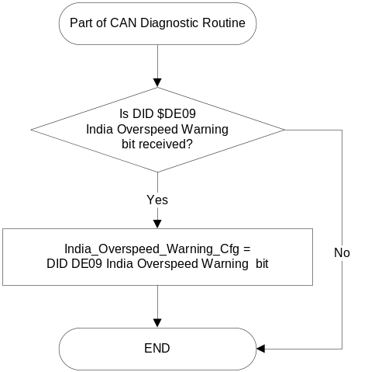

- State Matrix for India_Overspeed_RTT
Operational Mode | Internal Supplier Config Bit* | India  _Overspeed _Warning  _Cfg | VehVActlEng  _D_Qf  Signal | Veh_V_ActlEng  Signal | India_Overspeed  _RTT | OverSpeedChime  Flag_Control | Headlamps_On  _Chime_Status  _Flag
NORMAL  or  CRANK | RTT | Enabled | (0x2 i 0x3) | <India_LSW_Low | Inactive | Inactive | Inactive
NORMAL  or  CRANK | RTT | Enabled | (0x2 i 0x3) | >India_LSW_Low  <India_LSW_High | No State Change | No State Change | Inactive
NORMAL  or  CRANK | RTT | Enabled | (0x2 i 0x3) | >India_LSW_High  <India_HSW_Low | Active | Active | Inactive
NORMAL  or  CRANK | RTT | Enabled | (0x2 i 0x3) | > India_HSW_Low &  < India_HSW_High | Active | Active  No State Change | No State Change
NORMAL  or  CRANK | RTT | Enabled | (0x2 i 0x3) | >= India_HSW_High | Active | Active  Inactive | Active
NORMAL  or  CRANK | RTT | Enabled | X | Missing as per 1.4.1 | Inactive
NORMAL  or  CRANK | RTT | Enabled | != (0x2 i 0x3) | X | Inactive
All Other Cases |  |  |  |  | Inactive
X=Don’t Care
Not Received = The state when a DIAG_SESSION_TIMER is active and the DID has not been received
*Internal Supplier Config Bit: This may not be needed if the cluster only supports one method for the India Overspeed Warning.
Notes:
- Over_Speed_Chime_Status_Flag is also set Active as per GCC Overspeed Warning Telltale, Fixed Dedicated RTT, and Chime section and that function is mutually exclusive with the function in this section.
- Over_Speed_Chime_Status_Flag once set to Active remains Active until vehicle speed is less than India_LSW_Low. This is to insure it is only sounded once upon exceeding India_LSW_High.
- Headlamps_On_Chime_Status_Flag is also set to Active as per Headlamp-On-Reminder-Chime section and that function is mutually exclusive with the function in this section.

- State Matrix for India_Overspeed_Telltale
Operational Mode | Internal Supplier Config Bit* | India_ Overspeed  _Warning  _Cfg | DIAG_  SESSION_TIMER | DIAG_DID_  6030,1,7 (Overspeed Warning) | DIAG_DID_  61A5,4,6  (all warning  lamps) | VehVActlEng  _D_Qf  Signal | Veh_V_ActlEng  Signal | India  _Overspeed  _Telltale | OverSpeedChime  Flag_Control | Headlamps_On  _Chime_Status  _Flag
NORMAL | Telltale | Enabled | Not Active | X | X | (0x2 i 0x3) | <India_LSW_Low | Inactive | Inactive | Inactive
NORMAL | Telltale | Enabled | Not Active | X | X | (0x2 i 0x3) | >India_LSW_Low  <India_LSW_High | No State Change | No State Change | Inactive
NORMAL | Telltale | Enabled | Not Active | X | X | (0x2 i 0x3) | >Inida_LSW_High  <India_HSW_Low | Active | Active | Inactive
NORMAL | Telltale | Enabled | Not Active | X | X | (0x2 i 0x3) | > India_HSW_Low &  < India_HSW_High | Active | Active  No State Change | No State Change
NORMAL | Telltale | Enabled | Not Active | X | X | (0x2 i 0x3) | >= India_HSW_High | Active | Active  Inactive | Active
NORMAL | Telltale | Enabled | Not Active | X | X | X | Missing as per 1.4.1 | Inactive | Inactive | Inactive
NORMAL | Telltale | Enabled | Not Active | X | X | != (0x2 i 0x3) | X | Inactive | Inactive | Inactive
NORMAL  or  CRANK | Telltale | Enabled | Active | Not Received | Not Received | (0x2 i 0x3) | <India_LSW_Low | Inactive | Inactive | Inactive
NORMAL  or  CRANK | Telltale | Enabled | Active | Not Received | Not Received | (0x2 i 0x3) | >India_LSW_Low  <India_LSW_High | No State Change | No State Change | Inactive
NORMAL  or  CRANK | Telltale | Enabled | Active | Not Received | Not Received | (0x2 i 0x3) | >Inida_LSW_High  <India_HSW_Low | Active | Active | Inactive
NORMAL  or  CRANK | Telltale | Enabled | Active | Not Received | Not Received | (0x2 i 0x3) | > India_HSW_Low &  < India_HSW_High | Active | Active  No State Change | No State Change
NORMAL  or  CRANK | Telltale | Enabled | Active | Not Received | Not Received | (0x2 i 0x3) | >= India_HSW_High | Active | Active  Inactive | Active
NORMAL  or  CRANK | Telltale | Enabled | Active | Not Received | Not Received | X | Missing as per 1.4.1 | Inactive | Inactive | Inactive
NORMAL  or  CRANK | Telltale | Enabled | Active | Not Received | Not Received | != (0x2 i 0x3) | X | Inactive | Inactive | Inactive
NORMAL  or  CRANK | Telltale | Enabled | Active | ON (0X1) | X | X | X | Active | Inactive | Active
NORMAL  or  CRANK | Telltale | Enabled | Active | X | ON (0x1) | X | X | Active | Inactive | Inactive
All Other Cases |  |  |  |  |  |  |  | Inactive
X=Don’t Care
Not Received = The state when a DIAG_SESSION_TIMER is active and the DID has not been received
*Internal Supplier Config Bit: This may not be needed if the cluster only supports one method for the GCC Overspeed Warning.
Notes:
- Over_Speed_Chime_Status_Flag is also set Active as per GCC Overspeed Warning Telltale, Fixed Dedicated RTT, and Chime section and that function is mutually exclusive with the function in this section.
- Over_Speed_Chime_Status_Flag once set to Active remains Active until vehicle speed is less than India_LSW_Low. This is to insure it is only sounded once upon exceeding India_LSW_High.
- Headlamps_On_Chime_Status_Flag is also set to Active as per Headlamp-On-Reminder-Chime section and that function is mutually exclusive with the function in this section.

Figure 3: India Overspeed Low Speed Warning Chime Function

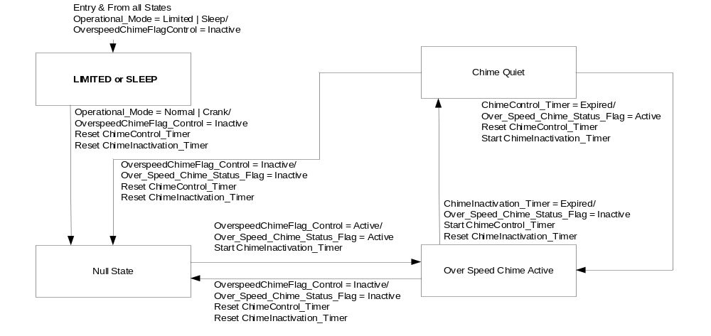

Operation Description (supports algorithm flowchart /state diagram)

- The Fixed/Dedicated RTT and Fixed LED Telltale are mutually exclusive on any given IPC. The Fixed/Dedicated RTT is the preferred implementation (cost), followed by the Fixed LED Telltale.
- The India Overspeed warning shall be a fixed TT or fixed/dedicated RTT and may share the same space as the GCC Overspeed TT/RTT as the function is mutually exclusive.

Function Safety Classification (EMC)

Class B

Memory Storage

Variable Name | Type of Storage | Description | Value at Battery Connect | Value at Module Wake-up | Minimum Range | Initial Value from Cluster Plant | Units
Internal Supplier Config Bit | EEPROM | NVM bit programmed at supplier to enable Fixed/Dedicated RTT, LED Telltale, | Use Stored Value | Use Stored Value | - | RTT  or  Telltale | -

Parameter Name | Description | Value at  Battery Connect | Value at  Module Wake-up
India_Overspeed_Telltale | Used to control the state of the LED | OFF | OFF
India_Overspeed_RTT | Used to control the state of the Fixed/Dedicated RTT | OFF | OFF
OverSpeedChimeFlag  _Control | Used as part of the logic to control the Over_Speed_Chime_Status_Flag | Inactive | Inactive
Over_Speed_Chime  _Status_Flag | Used to control the state of the Overspeed chime. | Inactive | Inactive
Veh_V_ActlEng | Used to control state of the Overspeed Flags | See Speedometer Gauge Section
VehVActlEng_D_Qf | Used to control state of the Overspeed Flags | See Speedometer Gauge Section
DIAG_DID_6030,1,7 (Overspeed Warning) | Warning Lamp Status 3, byte 1, bit 7 (Overspeed Warning) | 0 (0x0) | 0 (0x0)
DIAG_DID_61A5,4,6 (all warning lamps) | Indicator Lamp Control 2, byte 2, bit 6 (all warning lamps) | 0 (0x0) | 0 (0x0)
India_Overspeed  _Warning_Cfg | Configures cluster to enable or disable India Overspeed Warning | Use Stored Value | Use Stored Value
Operational_Mode | 4 state indicator for cluster operational mode | Limited | Limited, Normal or Crank

Parameter Name | Description | Range | Units | Offset | Resolution | Init Value
India_LSW_Low | The downward trip point for India high speed warning in km/h | 0-127 | km/h | 0 | 1 | 74 km/h
Inida_LSW_High | The upward trip point for India high speed indication in km/h | 0-127 | km/h | 0 | 1 | 77 km/h
India_HSW_Low | The downward trip point for India high speed warning in km/h | 0-127 | km/h | 0 | 1 | 113 km/h
India_HSW_High | The upward trip point for India high speed indication in km/h | 0-127 | km/h | 0 | 1 | 116 km/h
ChimeInactivation_Timer | Timer used as part of logic to set Over_Speed_Chime_Status_Flag to Inactive. | NA | Seconds | 0 | NA | 5seconds
ChimeControl  _Timer | Timer used as part of logic to set Over_Speed_Chime_Status_Flag to Active. | 0 – 180 | Seconds | 0 | 5 | 115seconds

Parameter Name | Description | Value at  Battery Connect | Value at  Module Wake-up
DIAG_SESSION_TIMER | Timer used to time-out a diagnostic session | Not Active | Not Active
Self_Test_Entry_Bulb_Check_ Timer | Timer used in diagnostic session to do a self check of telltales | Not Active | Not Active

Prove Out

None

Reconfigurable Telltale

- Table India_Overspeed_RTT to MC Warning Message ID
MC_Status_Flag | Mc Warning - Message ID
India_Overspeed_RTT | W2042
Note: J.011 symbol must be used with W2042

Message Center Msg

None

Error Handling

Missing Message Strategy
The signals will be declared missing as per the Diagnostics section of this SPSS.

DTCs states and history will be determined as per the Diagnostics section of this SPSS. See
Speedometer Gauge section for DTCs.

Invalid or Unknown Strategy
The signals will be declared invalid as per the Diagnostics section of this SPSS.

DTCs states and history will be determined as per the Diagnostics section of this SPSS. See
Speedometer Gauge section for DTCs.

Diagnostics

Self Test

Bulb illuminated during self test as per Self_Entry_Bulb_Check_Timer

Engineering Test Mode

Reference section “Dealer / Engineering Test Mode (ETM)”.

Part II Performance

DIDs
Number | PID / CommonID Name | DID Type
6030, 1,7 | Warning Lamp Status 3, byte 1, bit 7 (Overspeed Warning) | Bit Mapped
61A5,4,6 | Warning Lamp Status 2, byte 4, bit 6 (all warning lamps) | Bit Mapped

Supported Diagnostic Trouble Codes (DTCs)
DTC | Description | When Logged
C10000 | Lost communication with ECM/PCM | Message missing for more than 5 seconds and India_Overspeed_Warning_Cfg = Enabled

DID DExx
Block  Num | Block Description | Size (bits) | Type | Byte(s) | Bits | State: Description | "0" | "1" | Default | Comments/  Information
PACKETED BLOCKS
$xx | Option Content (B&A) | 32 | 1 | * | * | India Overspeed Warning | Disabled | Enabled | Disabled | Must be enabled for India per regulation.
*Byte and bit location to be identified in Part II Specification for this cluster

Reference Specification

FO-0007 FOUR WHEEL DRIVE MODE DISPLAY
FO-0008 FOUR WHEEL DRIVE FAULT INDICATOR

IS-0001 WARNINGS/INDICATORS/DISPLAYS PROVEOUT
IS-0046 INSTRUMENTATION MATERIAL RESISTANCE TO CLEANING
IS-0052 OPERATING VOLTAGES - FUNCTIONAL/PERFORMANCE
IS-0069 FUNCTIONAL IMPORTANCE CLASS
IS-0324 WINDSHIELD & OTHER REFLECTIONS
IS-0327 WARNING INDICATOR EVALUATION
IS-0329 FLICKERING OF LAMPS
IS-0379 NORTH AMERICAN WARNINGS AND INDICATORS STRATEGY

IL-0017 TELLTALE AND INTERIOR ILLUMINATION COLOR
IL-0021 CRAFTSMANSHIP - DISPLAYS
IL-0023 CLARITY/LEGIBILITY/READABILITY
IL-0025 INTERIOR ILLUMINATION INTENSITY
IL -0027 VISUAL CONTRAST
IL -0043 OPERATIONAL ENVIRONMENT FUNCTIONALITY
IL -0045 COLOR
IL -0047 TELLTALE; INDICATOR AND DISPLAY LIGHT INTENSITY
IL -0048 ILLUMINATION ACCEPTABILITY

03-0661 PLACEMENT: CONTROL AND DISPLAY LOCATIONS
03-0662 PLACEMENT: LOGICAL GROUPING FUNCTION AND USAGE
03-0664 PLACEMENT: DOWN VISION TO COMPONENTS WITH HIGH VISUAL DEMAND
03-0665 PLACEMENT: EXPECTED LOCATIONS OF CONTROLS AND DISPLAYS VDS
03-0670 INTERIOR VISIBILITY
03-0671 INTERIOR VISIBILITY: REFLECTIONS FROM COMPONENTS & SURFACES
03-0672 INTERIOR VISIBILITY: REFLECTIONS IN DISPLAYS
03-0673 INTERIOR VISIBILITY: VISUAL OBSCURATIONS
03-0674 INTERIOR VISIBILITY: ILLUMINATION CONTROLS / DISPLAYS
03-0675 INTERIOR VISIBILITY: VEILING GLARE
03-0677 INTERIOR VISIBILITY: SUNLIGHT WASHOUT
03-0681 IDENTIFICATION: CHARACTER AND SYMBOL SIZE
03-0682 IDENTIFICATION: LEGIBILITY
03-0685 IDENTIFICATION: SYMBOLS, ABBREV FOR CONTROL
03-0721 LOGIC OF OPERATION: OPERATIONAL STEREOTYPES
03-0722 LOGIC OF OPERATION: INTERPRETATION
03-0723 LOGIC OF OPERATION: USE OF SYSTEMS WITH VISUAL DISPLAYS

Revision History

SPSS Module Revision History

Revision Level | Name | Change Description | Date
1.0 | JBlatchf | Initial Release | 3/6/2017
2.0 | J. Blatchford | This update addresses India updated regulation relative to Overspeed Warning as per RCN IND-R-013113/3 released into Ford system 05May2018 and described updates to India Regulation AIS-145_F. This update changes overspeed warning such that the lower speed warning sounds an audible warning not less than 1cycle/2minutes. Prior regulation only required the audible warning to sound once upon entering the lower speed warning condition. This update also increases the threshold for the high speed warning from 100 km/h to 120 km/h. This update must be made for all vehicles manufactured on or after 01Jul2019 or the vehicle will not be saleable in the Indian market. Changes highlighted in yellow.  - 1.1 Functional Description: Added description of new RCN regulation number and impact. Struck out prior like information (not highlighted in yellow).  - 1.3.3.1.1: Added symbol number.  - 1.3.3.3: Added description relative to lower speed warning.  - Table 1.2: Updated  - Table 1.3: Updated  - Figure 3: Added Figure only title is highlighted in yellow.  - 1.3.5.4: Added variables and timers. Updated HSW to new 120 km/h trigger point. GCC values were used as they use 120 km/h and speedometer bias is taken into consideration.  - Table 1.4: Added W# and note relative to the symbol. | 6/19/18

